EUROPEAN HUMANITIES UNIVERSITY
Academic Department of ____________________
Study programme ____________________
KIRILL KALASHNIKOV
___ year student
A SYSTEM FOR CREATING 3D GAME MAPS FROM VIDEO
BACHELOR PROJECT
Business analysis block: Introduction, Chapter 1, Chapter 2
Project type: individual
Supervisor: Assoc. Prof., Cand. Sc. (Eng.) S. V. Avdeychik
Vilnius, 2026
TABLE OF CONTENTS

INTRODUCTION 3
Relevance and Problem 3
Goal and Objectives 3
Object and Subject 4
Methods 4
Glossary 4
1. ANALYTICAL PART 6
1.1. Current State 6
1.2. Review of Sources 7
1.3. Analysis of Analogs 8
1.4. Chapter Conclusions 12
2. SYSTEM REQUIREMENTS 13
2.1. Vision and Goals 13
2.2. Stakeholders and Users 14
2.3. Project Scope 15
2.4. Solution Concept 16
2.5. Functional Requirements 17
2.6. Use Case Scenarios 24
2.7. Non-Functional Requirements 25
2.8. Legal and Ethical Requirements 26
2.9. Risks 27
2.10. Chapter Conclusions 28
LIST OF REFERENCES 29
APPENDIX 1. Backlog 32
APPENDIX 2. Diagrams 36
STATEMENTS 43
Use of Artificial Intelligence 43

INTRODUCTION

Relevance and Problem
Who has the problem. People who build small games and prototypes without a 3D artist: indie developers and game jam participants, level designers at small studios, makers of tabletop models and dioramas, game development teachers and students. More than 18,000 games were released on Steam in 2025 [1]. In Fortnite, the number of map creators grew from 24,000 to 70,000 during 2024 [2]. By the end of 2025, more than 35,000 Roblox creators were in its payout programme [3].
What the problem is. A person wants to build a level from a real place: a corner of a desk, a patch of floor, a model. A phone with a LiDAR depth sensor captures such a place in metres [4], [5]. But scanning apps deliver a model for viewing, not a level [6]–[9]. A character cannot walk on it straight away. The walkable surface, mesh simplification, scale and the walkability check are all done by hand in a 3D editor and a game engine. Without 3D modelling skills the real place never reaches the prototype; with those skills it costs a lot of manual work. A bad capture also looks like a good one: the scanner always produces a model, and the defect shows up only in the engine.
Why now. Every iPhone Pro since the iPhone 12 Pro and the iPad Pro have a LiDAR sensor [5], [10]. Browsers and popular game engines open the glTF 2.0 format [11]. The number of people who make games and maps is growing [1]–[3]. The methods an automatic build relies on — volumetric depth fusion, surface extraction and mesh simplification — are well established [12]–[15]. What is missing is a product that joins them into a "capture it — walk the level" path.
Solution. NVC Maps is a service that turns a short capture of a small area taken on an iPhone with a depth sensor into a game level. The phone app records and checks the capture, the server builds a visual mesh and a separate collision mesh for the character, and in the browser the map can be walked before it is taken into a game engine. An unsuitable capture is rejected with a reason.

Goal and Objectives
Goal. Shorten the path from capturing a real area to a walkable game level to a single walk-around with a phone, without manual geometry fixing.
Objectives.
- Identify where time and data are lost in the current path from capture to level.
- Determine what existing scanners and research solutions lack for producing a walkable level directly.
- Set measurable success indicators with baseline and target values.
- Describe what the user does, what the system checks, and when it rejects a build.
- Define the set of reference captures and checks used to accept the result, together with legal constraints and risks.

Object and Subject
Object — the process of creating a game level from a real place: from capture to the first check of the level in a game engine.
Subject — the automatable part of this process: checking the capture, building the map with a separate collision mesh for the character, checking walkability in the browser and delivering the package for game engines.

Methods
The requirements were gathered as follows:
- Document analysis. The project's technical specification and pipeline blueprint, the glTF 2.0 specification [11], ARKit and RoomPlan documentation [16], the GDPR [17], WCAG 2.1 [18].
- Literature review. Research on surface reconstruction, mesh simplification and turning video into interactive scenes [4], [12]–[15], [19]–[22].
- Benchmarking of analogs. Comparison of nine solutions based on public descriptions, documentation and prices [6]–[9], [16], [19], [23], [24] (section 1.3).
- Proto-persona. The persona is based on the document and market analysis. No user interviews were conducted; validating the persona with real people is listed as a risk (section 2.9).
The techniques follow BABOK v3 [25]: document analysis, benchmarking and market analysis, process modelling, user stories, MoSCoW prioritisation.

Glossary
Term | Meaning
Capture | A recording of an area on the phone: video, camera poses, metadata and depth frames in one file
Camera poses | Where the phone was and where it pointed at each moment of the recording
Visual mesh (map.glb) | The part of the map the player sees
Reconstruction method | How the server obtained the surface; for a suitable capture, LiDAR depth fusion
Collision mesh (collision.glb) | An invisible simplified mesh the character walks on
Map package | Five files: visual mesh, collision mesh, manifest, bounds, report
Job | One map build on the server with the status "queued", "building", "ready" or "rejected"
Rejection | The service's answer "the map cannot be built" with a reason instead of a map
Reference capture | One of four saved captures used for acceptance: two suitable and two unsuitable
Walk check | Walking a character on the collision mesh in the browser before the package is delivered

1. ANALYTICAL PART

1.1. Current State

How the Task Is Solved Today (AS-IS)
There is no ready-made "capture a place — get a level" path. People assemble it themselves from several tools. The process is shown in the activity diagram (Image A.2.1).
The steps, participants and losses of the current process are given in Table 1.1.
Table 1.1. Steps of the current process and losses
Step | Who | Tool | Where time and data are lost
1. Capture the place | Level author | Phone scanner: Polycam, Scaniverse, KIRI Engine | The app does not say whether the capture is suitable for a game level
2. Export the model | Level author | OBJ, FBX or GLB export; some formats only on a paid plan [26] | A dense model with debris along the edges and no game budget
3. Clean up and simplify | Level author or 3D artist | Blender | Manual work that needs skills. Scale is easily lost on export
4. Build a collision mesh | Same | Blender or engine | A separate simplified mesh made by hand. A splat does not support the character, so the collision mesh is built separately anyway [7]
5. Import into the engine and walk | Developer | Godot, Unity, Unreal | Walkability is visible only here. Errors from step 1 or 4 are found at the very end
6. Redo | Everyone | All tools | The same result cannot be reproduced: every step is manual

Who is involved. Most often a single person: an indie developer, a level designer, a model maker or a student. In a studio, steps 3–4 may be done by a 3D artist, which adds file hand-offs between people.
Where time is lost. Steps 3–4: manual cleanup, simplification and collision mesh building. Steps 5–6: a capture defect is found last, and the cycle starts again.
Where data is lost. The metric scale measured by the sensor is lost during export and manual rescaling. Information about how the capture was taken (camera path, depth) does not reach the model. Afterwards it is impossible to explain why the level came out bad.

Illustrative Example
The persona Anya (section 2.2) takes part in a 48-hour game jam. The theme is "small world", and she wants to build a level from her desk with books and a mug. She scans the desk in Polycam and gets a good-looking model of several hundred thousand triangles. Godot imports it, but the character falls through: the model has no separate collision mesh, and the desk edges are ragged. Anya opens Blender, cleans the edges by hand, simplifies the model and builds an invisible collision mesh from cubes. On export the scale is lost, and the character ends up the size of the mug. After the second attempt it turns out that one book was missing from the capture: Anya moved too fast. The level takes half a day of the 48-hour jam, and in the end she replaces the desk with cubes.
The example shows three losses: time spent on manual fixing, a capture defect found late, and lost scale. These are what the product addresses.

How It Will Be (TO-BE)
A person walks around the area with a phone for 10–30 seconds. The app checks the recording at once and either sends it to the server or asks for a retake with a clear reason. The server builds the map itself: a visual mesh, a separate lightweight collision mesh and a report, keeping the sensor scale. The person walks the map in the browser and downloads the package into the engine. Manual steps 3–4 and the late check in step 5 disappear (Image A.2.2).

1.2. Review of Sources
The review uses 33 sources, 10 of them scientific. The sources fall into four groups: reconstruction methods, scene representation, standards and regulations, market and analogs.
Reconstruction methods. The classic path from depth to surface is described by Curless and Levoy [13] and in KinectFusion [12]: depth maps with a known camera position are accumulated in a volumetric grid, from which the surface is extracted with marching cubes [14]. The method is robust to noise in a single frame but depends entirely on pose accuracy: trajectory errors smear the surface. Two product decisions follow. Camera poses are mandatory, and without them the build is rejected. The capture area is small, so the accumulated trajectory error does not have time to grow. Quadric error simplification [15] reduces a mesh to a set number of triangles with controlled loss of shape — the basis of the strict visual mesh and collision mesh budgets.
Sensor accuracy. An evaluation of the iPhone 12 Pro LiDAR [4] shows centimetre accuracy on small objects captured from up to a few metres. This is consistent with choosing a small zone of about 80 × 80 cm and capturing from a low height. Depth Anything V2 [21] estimates depth from a single frame with a neural network; this is an estimate, not a sensor measurement, so in the product it is only a disabled fallback mode.
Scene representation. Gaussian splatting [20] brought photorealistic real-time scene viewing, and scanners adopted it quickly [6], [7], [23]. But a splat has no surface a character can walk on: even Polycam's Unreal guide takes the character's collision from a separate mesh [7]. Video2Game [19] is the work closest to the product: video turns into a scene with collision for the character that runs in a browser. However, it requires training a neural representation for each scene and remains a research pipeline rather than a service. Conclusion for the product: a beautiful image and a game-ready collision mesh are different tasks, and the product solves the second.
Standards and regulations. glTF 2.0 [11] sets metres as the unit and Y as the up axis and is read by browsers and engines, which makes the package portable without conversion. The GDPR [17] requires a legal basis, data minimisation and the right to erasure: a capture of a room may accidentally include people. WCAG 2.1 [18] sets a measurable accessibility level for the web client. The requirements elicitation techniques come from BABOK v3 [25].
What each group of sources implies for the requirements in Chapter 2 is shown in Table 1.2.
Table 1.2. Conclusions from the sources for the requirements
Sources | What follows | Where in the requirements
Depth fusion [12], [13], Open3D [22] | Depth maps with known poses fuse into a surface; without poses there is no result. Ready implementations are open (MIT) | Poses are mandatory, otherwise rejection: US-3.2; licences: 2.8
Marching cubes [14], quadric simplification [15] | The surface is built automatically, and the triangle count can be strictly limited | Map budget: KPI-4, US-3.3
iPhone 12 Pro LiDAR [4], devices [5], [10] | Centimetre accuracy on a small area; depth is available only on Apple Pro devices | 80 × 80 cm zone, iOS platform: 2.3
Gaussian splatting [20], splats in engines [7], [23] | A splat has no physical surface; the collision mesh is added as a separate model | Separate collision mesh: US-5.1; splats out of scope
Depth Anything V2 [21] | Single-frame depth is a neural estimate, not a measurement | Build without LiDAR is a disabled mode: 2.3
Video2Game [19] | Video becomes an interactive scene with collision, at the cost of per-scene training; this is research, not a product | Walk check in the browser: US-4.1; no per-scene network training
glTF 2.0 [11], RoomPlan [16] | An open format with metres and Y up; RoomPlan builds a room plan, not the surface of an area | GLB package and manifest: US-5.2
GDPR [17], WCAG 2.1 [18], BABOK [25] | Legal basis, minimisation, erasure; AA accessibility; elicitation techniques | 2.8, NFR-9; methods in the Introduction
Market [1]–[3], analogs [6]–[9], [23], [24] | There are many game creators and more every year; scanners deliver a model, not a level | Segments: 2.2; analogs: 1.3

Conclusion. Surface reconstruction and simplification technologies are mature [12]–[15], [22]. The phone sensor is accurate on a small area [4]. The novelty of the product lies not in the algorithms but in joining them into a verifiable path from capture to a walkable level with an honest rejection.

1.3. Analysis of Analogs
Nine solutions were reviewed. Commercial: Polycam [7] (subscription of about $27 per month [26]), Scaniverse [6] (Niantic Spatial), KIRI Engine [8] ($50–80 per year), RealityScan [9] (Epic Games, export via Sketchfab to Unreal), Luma [23] (splats, Unreal plugin), World Labs Marble [24] (generates a 3D world from text, photos or video and exports a collider mesh as GLB), and the Apple RoomPlan API [16], which builds a room plan from walls and furniture. Research and open: Video2Game [19] and the manual path with COLMAP [27], Open3D [22] and Blender.
Polycam is a widely used scanner with LiDAR and photogrammetry. Its strengths are model quality and a wide choice of formats. Turning its output into a level takes manual work: there is no collision mesh, the model is dense, and some formats require a paid plan [26].
Scaniverse is a free Niantic Spatial scanner with meshes and splats. In 2026 it added a package for robot simulators in which the mesh is derived from the splat [6], [28]. This is a step towards a simulation-ready scene, but not towards a lightweight game level.
KIRI Engine targets artists: retopology, PBR materials, export to Blender and Unreal [8]. The result is an asset for further work, not a walkable area.
RealityScan by Epic Games turns photos of an object into a 3D model and takes it into the Epic ecosystem: Sketchfab and Unreal [9].
Luma produces photorealistic splats and an Unreal plugin [23]. A splat has no surface for a character [20], and the vendor does not claim metric scale.
World Labs Marble is closest in output: it exports a separate collider mesh as GLB [24]. But the world is generated by a model rather than measured, so its scale is not real; the vendor does not claim a walkability check or rejection of an unsuitable capture [24].
Apple RoomPlan builds a room plan from walls, doors and furniture [16]. This is a diagram of a room, not the surface of a desk or a model.
Video2Game shows that the "video → walkable scene" path is possible [19], but it requires training for each scene and is not a product.
The manual path with COLMAP [27], Open3D [22] and Blender gives full control but requires skills and time and cannot be repeated with a single command.

Comparison by Criteria
The criteria are derived from the losses of the current process (Table 1.1): each step where time or data is lost has one criterion, and the last one shows where the analogs are stronger.
- Rejection (step 1) — rejection with a reason for a capture unsuitable for a level.
- Budget (steps 2–3) — the model fits a game budget without manual simplification.
- Metres (step 3) — the result keeps the real scale.
- Collision (step 4) — a separate lightweight mesh the character walks on.
- Walk (step 5) — walkability can be checked before import into the engine.
- Repeat (step 6) — processing the same capture again gives the same result.
- Image — high image and texture quality.
The analogs are assessed from public descriptions and documentation [6]–[9], [19], [23], [24]. The NVC Maps column shows target values: the product is under development. The results are summarised in Table 1.3.

Table 1.3. Comparison of analogs by criteria
Criterion | Polycam | Scaniverse | KIRI Engine | RealityScan | Luma | World Labs Marble | Video2Game | NVC Maps (target, planned)
Rejection (step 1) | — | — | — | — | — | — | — | ✓
Budget (steps 2–3) | — | — | ~ | — | — | — | — | ✓
Metres (step 3) | ✓ | ✓ | ✓ | — | — | ✕ | — | ✓
Collision (step 4) | ✕ | ~ | — | — | ✕ | ✓ | ✓ | ✓
Walk (step 5) | — | — | — | — | — | ~ | ✓ | ✓
Repeat (step 6) | — | — | — | — | — | — | — | ✓
Image | ✓ | ✓ | ✓ | ✓ | ✓ | ✓ | ✓ | ✕

Legend: ✓ — yes; ~ — partly; ✕ — no; — — not claimed by the vendor. Notes: Scaniverse exports a mesh for robot simulators [28]; KIRI Engine performs retopology [8]; World Labs Marble has a physics example in the browser [24]; for Polycam and Luma the character's collision is added as a separate mesh [7], [20].

What Is Missing
- A collision mesh in metres. Scanners with LiDAR keep the scale but do not claim a separate collision mesh, and in Polycam it is added by hand [7]. World Labs Marble exports a collider mesh, but its world is generated by a model, and its scale is not real.
- A walkability check before the engine. Only the research project Video2Game claims it, and World Labs Marble partly; scanners do not claim such a check.
- An honest rejection. No solution claims rejecting a capture unsuitable for a level with a reason.
- Repeatability and a game budget. No solution claims repeatable results and automatic fitting into a game budget.
Where the analogs are stronger. Image quality, textures, scene size (room, street), Android support. The product deliberately gives way here: its goal is a result that is fit for a game.

1.4. Chapter Conclusions
The identified problems and what the new solution must be able to do are summarised in Table 1.4.
Table 1.4. Problems and their links to epics and KPIs
No. | Problem | What the new solution must do | Epic | KPI
P1 | A bad capture looks like a good one; the defect is found in the engine | Check the recording on the phone and reject it with a reason | E1, E3 | KPI-3
P2 | The collision mesh and simplification are done by hand | Build the visual mesh and a lightweight collision mesh automatically | E3, E5 | KPI-1, KPI-4
P3 | Walkability is visible only in the engine | Let the user walk the map in the browser | E4 | KPI-1, KPI-2
P4 | The sensor scale is lost along the way | Keep metres and record units and axes in the manifest | E5 | KPI-1
P5 | The path from capture to level is long and not repeatable | Accept the capture, build the map on the server, show the status | E2, E3 | KPI-2
P6 | Without a LiDAR phone the product cannot be checked | Open the reference jobs via a test link | E6 | KPI-1, KPI-3

2. SYSTEM REQUIREMENTS

2.1. Vision and Goals

Vision
NVC Maps turns a short video of a real place into a game level. A person walks around a small area with an iPhone, and the service builds a map a character can walk on, checks it in the browser and delivers it as a file for any engine. A bad capture gets an honest rejection with a reason instead of a broken map.

Business Goals
The business goals are listed in Table 2.1.
Table 2.1. Business goals
ID | Goal
BG-1 | Remove manual geometry fixing from the path between capture and a walkable level
BG-2 | Shorten the time from capture to the first check of the level
BG-3 | Never pass off an unsuitable capture as a finished map
BG-4 | Deliver a map that fits a game budget straight away

KPIs
Goal achievement is measured by four KPIs (Table 2.2).
Table 2.2. KPIs: baseline and target values
ID | Indicator | Baseline (today) | Target | How to measure
KPI-1 | Share of suitable reference captures that give a walkable level without manual fixing | 0%: scanners do not deliver a collision mesh for the character (section 1.3) | 100% on reference captures S1, S2 | Run of the reference captures, walk check: the character stands ≥ 5 s and crosses the map edge to edge
KPI-2 | Time from sending a capture to the first walk check | 2–4 h on the manual AS-IS path (author's estimate, steps 2–5 of section 1.1) | ≤ 15 min | Time between sending and opening the map in the browser on the reference captures
KPI-3 | Share of unsuitable captures rejected with a reason | 0%: scanners produce a model for any capture | 100% on reference captures N1, N2 | Run of the reference captures, reason text in the report
KPI-4 | Map weight | Dense scan without simplification: hundreds of thousands of triangles (author's estimate for the manual path, section 1.1) | Visual mesh ≤ 50,000 triangles; collision mesh ≤ 25% of the visual mesh and ≥ 100 faces | Metrics in the build report

2.2. Stakeholders and Users

Stakeholders
The stakeholders, their interests and influence are given in Table 2.3.
Table 2.3. Stakeholders: interest and influence
Stakeholder | Interest | Interest (H/M/L) | Influence (H/M/L)
Users: indie developers, level designers, model makers, teachers and students | Get a walkable level from a real place quickly | H | H
Product owner and team | The product solves the users' pain and runs without manual intervention; the team operates the service and the test link | H | H
Apple: iOS, ARKit, LiDAR, App Store | The app follows the App Store rules and asks for camera access clearly | L | H
Game engines and the glTF standard: Godot, Unity, Unreal, Khronos Group | Correct files in an open format | L | H
Data protection supervision (GDPR) | Faces and other people's premises do not enter the data without a legal basis | L | H
Hosting provider | Resources within the plan and limits | L | M
Authors of open libraries and models: Open3D, PyTorch, Depth Anything | Licences are respected | L | M
Competitors: Polycam, Scaniverse, KIRI, RealityScan, Luma, World Labs | They set users' expectations of a scanner | M | M
Communities: itch.io and game jams, game development courses, Fortnite Creative, Roblox | Tools that speed up game creation; a channel to users | M | L
Player on the finished map | Not to fall through the floor | H | L
Owner of the captured place | To know about the capture and be able to refuse | H | L
A person who accidentally appears in the frame | Not to end up in someone else's materials | H | L

Release scope and success criteria are agreed with the H/H groups. The rules of the L/H groups are followed as constraints: App Store, glTF, GDPR. The interests of the H/L groups are protected by product rules: the walk check, capture rules, and no close-up faces.

System Users (Actors)
- Capture operator — captures the area, passes the recording check, sends the capture.
- Map builder — follows the jobs, reads the report, walks the map in the browser.
- Game developer — downloads the package and takes it into the engine.
- Service team — issues and replaces the test link to the reference jobs.
Usually the first three roles are played by one person. The use case diagram is Image A.2.4.

Persona
The persona is based on the document and market analysis (Introduction, "Methods"). Validating it in interviews is listed as a risk (R6).
Anya, 24, indie developer. Makes small games in Godot in her spare time and takes part in 48–72-hour game jams. Takes 3D models from free libraries and finds Blender hard. Owns an iPhone 15 Pro.
- Goal: get a level with real texture within a couple of hours of a jam, for example from her own desk.
- Pain: the scanner gives a good-looking model, but the character cannot walk on it; building the collision mesh takes an evening she does not have at a jam.
- How the product helps: a 30-second walk around the desk, a walk check in the browser, GLB straight into Godot.

2.3. Project Scope

In Scope
- Capture on an iPhone or iPad with LiDAR: a zone of about 80 × 80 cm, walk-around, recording check, upload to the server.
- Map build at sensor scale: visual mesh, lightweight collision mesh, manifest, bounds, report.
- Rejection with a reason for an unsuitable capture instead of arbitrary geometry.
- Capture intake, job queue, status, package storage.
- Browser: capture upload, list of own jobs, report, walking on the collision mesh next to a capture frame, package download.
- Browser sign-in via a one-time link from the phone; a test link to four reference jobs.
- An open description of the exchange: what is accepted and what is returned.

Out of Scope
- A full game and a mandatory Unreal demo.
- Scaling the map for a specific character.
- Textures, a second level of detail, splats.
- Training an own depth model; a build without LiDAR affects the release only as a disabled mode.
- Android as a release platform.
- An admin panel, user accounts, roles, viewing other users' maps.

Assumptions and Constraints
The project's assumptions and constraints are given in Table 2.4.
Table 2.4. Assumptions and constraints
Type | Description | Consequence
Resources | One developer builds the product | If time runs short, Should and Could stories are dropped first (section 2.5)
Deadlines | The first release date is fixed by the project calendar | Scope is limited to Must stories; everything else comes after the release
Devices | Capture requires an iPhone Pro or iPad Pro with LiDAR [5], [10]; the simulator and the browser provide no depth | Without a device the product is checked with the four reference captures and the test link
Data access | Only the author's own captures and four reference captures are used: two suitable, two unsuitable. No third-party datasets | No organisation's consent is needed (statements); verification is limited to the reference captures
API and platform | Depth and poses are available only through ARKit on the device [29]; the map format is glTF 2.0 [11] | Release platform is iOS; package in GLB
Compute | Area size is limited by server compute: 80 × 80 cm by default | Quality thresholds are set for this size

2.4. Solution Concept
The solution has four parts (Image A.2.3):
- Capture app on the iPhone. Records video, camera poses, metadata and LiDAR depth, checks the recording and sends it to the server. The server address and the user's key are stored in the app.
- Intake service. Accepts a capture from the phone or the browser, queues a job, stores jobs, metrics and file links. Sending the same capture again returns the existing job.
- Build pipeline. A separate server process takes a job from the queue, builds the five-file package and puts it in storage. For an unsuitable capture it records a rejection with a reason.
- Web client. Shows the user's jobs, the report and walking on the collision mesh next to a capture frame. Sign-in is via a one-time link from the phone or a reusable test link to the reference jobs.
External systems: ARKit on the device, hosting with a database and file storage, game engines that open the package.

Alternatives
Two alternatives are compared in Table 2.5.
Table 2.5. Comparison of concept alternatives
Criterion | A. Build on the phone | B. Build on the server and check in the browser (chosen)
Compute | Limited by phone resources: depth fusion and simplification of the whole surface run on the device | The server builds without device limits; area size is configurable
Repeatability | The result depends on the phone model and app version | One builder and one configuration for all captures
Check without a phone | Impossible: the product cannot be checked without a LiDAR device | Reference jobs via the test link
Walk check | Only on the phone, small and inconvenient | In the browser on a large screen next to a capture frame
Privacy | Data never leaves the phone | Data is stored on the server: a legal basis and erasure are needed (2.8)
Cost | No server costs | Hosting costs

Rationale. Option B wins on repeatability, checking without a device and convenience of the walk check, which directly supports KPI-1 to KPI-3. Its drawbacks — privacy and cost — are covered by the requirements in 2.8 and by risks R4 and R5.

2.5. Functional Requirements

Epics
The epics and their links to business goals and KPIs are given in Table 2.6.
Table 2.6. Epics and their links to goals
Epic | Name | Business goal | KPI
E1 | Capture and recording check | BG-3 | KPI-3
E2 | Upload and jobs | BG-2 | KPI-2
E3 | Build, report and quality | BG-1, BG-3, BG-4 | KPI-1, KPI-3, KPI-4
E4 | Walk check in the browser | BG-1, BG-2 | KPI-1, KPI-2
E5 | Package for the engine | BG-1, BG-4 | KPI-1, KPI-4
E6 | Service operation | BG-2 | KPI-1, KPI-3

Acceptance criteria are written in the Given / When / Then format. The full backlog in one table is in Appendix 1.
Mock-ups of the key stories US-1.2, US-2.3, US-3.1 and US-4.1 are shown in Image 2.1; all screens are on the project website.
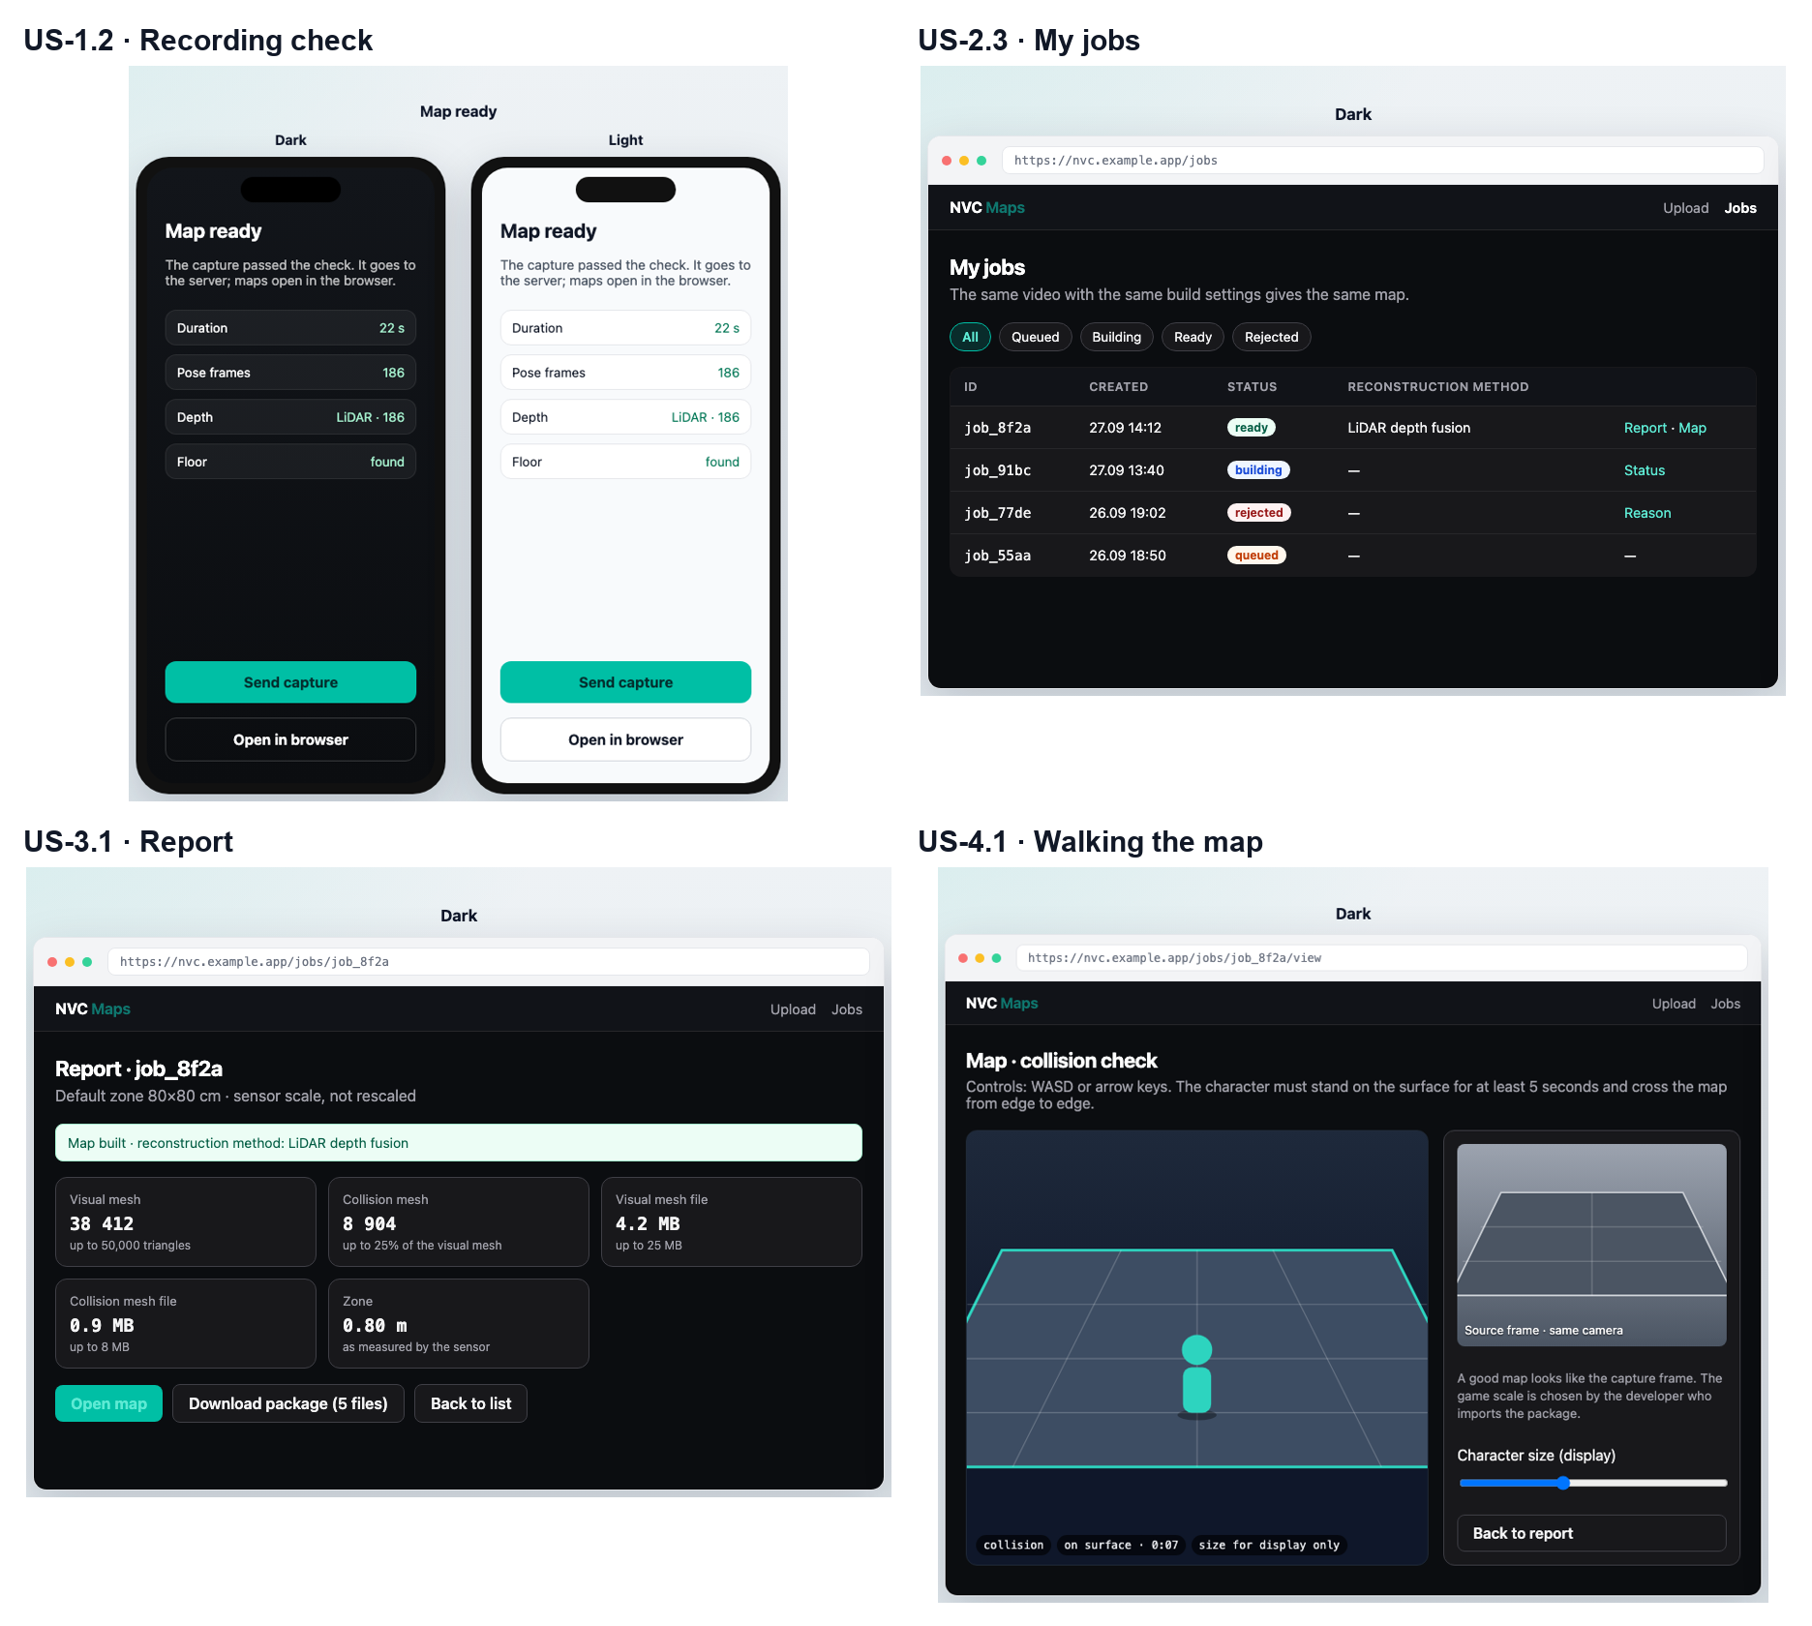
Image 2.1. Mock-ups of the key stories

E1. Capture and Recording Check
The epic's stories and acceptance criteria are in Table 2.7.
Table 2.7. Stories of epic E1. Capture and recording check
ID | Story | Acceptance criteria | MoSCoW
US-1.1 | Recording the zone. As a capture operator, I want to record an area on a phone with LiDAR so that I get a capture with depth in metres. | 1) Given a phone with LiDAR and the camera tracking its position, when the operator starts recording, then a 0.8 × 0.8 m zone is fixed on the floor. 2) Given the recording has stopped, when the capture is saved, then it contains video, camera poses, metadata and depth frames. 3) Given the camera is not yet tracking its position, when the operator tries to start recording, then the "Record" button is disabled and the hint "AR is starting — move the camera slowly over the floor" is shown. 4) Given recording has run for 30 s, when the time is up, then recording stops automatically. | Must
US-1.2 | Recording check before upload. As a capture operator, I want to know at once whether the recording is usable so that I do not send a defective capture and can retake it on the spot. | 1) Given a recording of 10–30 s, a camera path ≥ 0.28 m, a view-angle change ≥ 90°, a zone width ≤ 0.92 m and a gap between poses ≤ 0.5 s, when the check finishes, then "Map ready" and the "Send" button are shown. 2) Given a recording shorter than 10 s, when the check finishes, then "The recording must last 10 to 30 seconds" is shown. 3) Given a camera path shorter than 0.28 m, when the check finishes, then "Walk around the zone" is shown. 4) Given a view-angle change under 90°, when the check finishes, then "The views are too similar — walk around and show all sides" is shown. 5) Given a zone wider than 0.92 m, when the check finishes, then "The zone is too large — capture an area of about 80×80 cm" is shown. 6) Given a gap between poses longer than 0.5 s, when the check finishes, then "The gap between frames is too large — retake more smoothly" is shown. 7) Given any check has failed, when the operator views the result, then only "Retake" is available instead of "Send". | Must
US-1.3 | Walk-around hint. As a capture operator, I want to see during recording how much more to walk so that I capture the area on the first attempt. | 1) Given recording has run for 5 s or more, when the camera path is shorter than 0.28 m, then the hint "Don't stand still — walk slowly around the zone" is shown. | Should

E2. Upload and Jobs
The epic's stories and acceptance criteria are in Table 2.8.
Table 2.8. Stories of epic E2. Upload and jobs
ID | Story | Acceptance criteria | MoSCoW
US-2.1 | Upload from the phone. As a capture operator, I want to send the recording to the server with one button so that the build starts without a manual command. | 1) Given the check has passed, when the operator taps "Send", then a job with the status "queued" is created. 2) Given the upload failed because of the network, when the error arrives, then the reason is shown as text and the upload can be repeated. 3) Given a job for this capture already exists, when the operator sends the same capture again after a network error, then the same job is returned and no second build starts. 4) Given the user already has three builds running, when they send another capture, then no job is created and "Wait for the current builds to finish: there are already three" is shown. | Must
US-2.2 | Upload from the browser. As a map builder, I want to upload a saved capture through a browser form so that I can build a map without a phone. | 1) Given the upload form is open, when a file without video, poses or metadata is selected, then the missing parts are shown before sending. 2) Given the capture is complete, when the builder submits the form, then a job is created and the job list opens. 3) Given the file is larger than 400 MB, when the builder submits the form, then no job is created and "The capture file is larger than 400 MB" is shown. | Must
US-2.3 | My jobs in the browser. As a map builder, I want to open all my jobs in the browser with one button on the phone so that I can view reports and maps on a large screen. | 1) Given the user has jobs, when they tap "Open in browser", then the browser opens a list of all their jobs with date and status. 2) Given the one-time link has already been opened or more than 10 minutes have passed, when it is opened again, then the list does not open and "The link has already been opened or has expired" is shown. 3) Given another browser without a session, when the address of someone else's job is opened, then the map and report are not shown and "A link from the phone or a test link is required" is shown. | Must
US-2.4 | Status filter. As a map builder, I want to filter jobs by status so that I quickly find ready maps and rejections. | 1) Given the job list is open, when the "ready" filter is selected, then only ready jobs are shown. | Should
US-2.5 | Deleting a capture from the phone. As a capture operator, I want to delete an unneeded capture from "My maps" so that I free up phone storage. | 1) Given a capture card in "My maps", when the operator confirms deletion, then the capture files are deleted from the phone. | Could

E3. Build, Report and Quality
The epic's stories and acceptance criteria are in Table 2.9; the build rejection reasons with thresholds and messages are in Table 2.10.
Table 2.9. Stories of epic E3. Build, report and quality
ID | Story | Acceptance criteria | MoSCoW
US-3.1 | Build report. As a map builder, I want the report to show the status, reconstruction method and metrics so that I decide by numbers rather than by eye. | 1) Given the build succeeded, when the builder opens the report, then the status "ready", the reconstruction method "LiDAR depth fusion", the triangle counts of the visual and collision meshes and the file sizes are shown. 2) Given the build was rejected, when the builder opens the report, then instead of metrics the status "rejected" and the reason text from Table 2.10 are shown. | Must
US-3.2 | Rejection with a reason. As a map builder, I want an unsuitable capture to be rejected with a clear reason so that I do not mistake a defect for a map. | 1) Given the capture violates any condition in Table 2.10, when the build finishes, then the job status is "rejected" and the reason is the text from the same row of Table 2.10. 2) Given the status is "rejected", when the builder opens the job, then no placeholder geometry is delivered, and viewing and download are unavailable. 3) Given the capture meets all conditions in Table 2.10, when the build finishes, then the status is "ready" and there is no rejection. | Must
US-3.3 | Map within the game budget. As a game developer, I want to receive the map within budget so that I do not simplify it by hand. | 1) Given the reconstructed surface exceeds the budget, when the build runs, then the system itself simplifies the visual mesh to 50,000 triangles and the collision mesh to 25% of the visual mesh faces. 2) Given the build succeeded, when the package is written, then the visual mesh is ≤ 50,000 triangles and ≤ 25 MB, and the collision mesh is ≥ 100 faces and ≤ 8 MB. 3) Given the budget is still not met after simplification, for example the collision mesh has fewer than 100 faces or the visual mesh file is larger than 25 MB, when the build finishes, then the status is "rejected" with the reason "The map did not fit the game budget; no package was issued". | Must
US-3.4 | Comparing a repeated build. As a map builder, I want to compare a repeated build of the same capture with the first one so that I can confirm the result is reproducible. | 1) Given two builds of the same capture, when the builder compares the reports, then the reconstruction method is the same and the triangle counts differ by no more than 15%. | Should

Table 2.10. Build rejection reasons
Condition | Threshold | Reason shown to the user
No camera poses in the capture | The pose file is missing or empty | "The capture has no camera poses: retake the area"
Poses do not match the video | No pose within 0.25 s of a video frame | "Camera poses are damaged or do not match the video: retake the area"
Depth frames are damaged | Depth frames cannot be read or do not match the video in time | "LiDAR depth frames are damaged or do not match the video"
Zone not found | The zone centre was not recorded, or nothing remains inside the 80 × 80 cm square above the supporting surface | "The 80×80 cm zone was not found in the capture: walk around the area again"
Surface not reconstructed | Depth fusion produced an empty surface | "The surface could not be reconstructed: retake the area more slowly"
No walkable surface | The build report has the status "rejected" | "The capture produced no walkable surface: retake the area"
Map budget not met | Any threshold of US-3.3 is not met after simplification | "The map did not fit the game budget; no package was issued"
Build too long | The build runs longer than 15 minutes | "The build did not finish in time: retake a shorter area"
Service failure | Any other build error | "The build stopped because of a service error. Send the capture again later"

E4. Walk Check in the Browser
The epic's stories and acceptance criteria are in Table 2.11.
Table 2.11. Stories of epic E4. Walk check in the browser
ID | Story | Acceptance criteria | MoSCoW
US-4.1 | Walking the map. As a map builder, I want to walk a character on the finished map in the browser so that I check walkability without a game engine. | 1) Given the build succeeded, when the builder opens the viewer, then the character stands on the collision mesh for at least 5 s and does not fall through. 2) Given the viewer is open, when the builder moves the character along the zone diagonal from one corner to the opposite corner (about 1.1 m), then the character completes the route without falling through or getting stuck. 3) Given the build was rejected or is still running, when the builder opens the viewer, then the map does not load, and the job status and the rejection reason, if any, are shown. | Must
US-4.2 | Capture frame next to the map. As a map builder, I want to see a capture frame next to the model so that I can compare the map with the real place. | 1) Given the viewer is open, when the map has loaded, then a capture frame from the same camera is shown next to it. 2) Given another browser without a session, when the address of a frame of someone else's job is opened, then the frame is not served. | Must
US-4.3 | Character height in the viewer. As a map builder, I want to change the character height in the viewer so that I can try the map for different games. | 1) Given the viewer is open, when the builder changes the character height, then the character changes, while the map geometry and the package files do not. | Should

E5. Package for the Engine
The epic's stories and acceptance criteria are in Table 2.12.
Table 2.12. Stories of epic E5. Package for the engine
ID | Story | Acceptance criteria | MoSCoW
US-5.1 | Package download. As a game developer, I want to download a five-file package so that I can open the map in my engine. | 1) Given the build succeeded, when the developer clicks "Download", then they receive map.glb, collision.glb, manifest.json, bounds.json, report.json. 2) Given the package has been downloaded, when both GLB files are opened in a glTF viewer, then they open without errors. 3) Given the job is still queued, building or rejected, when the developer requests the package, then no files are served and "A package exists only for a ready job" is shown. | Must
US-5.2 | Real scale and package description. As a game developer, I want to receive the map in sensor metres with an axis description so that I can set the character scale myself. | 1) Given the package has been downloaded, when the developer reads the manifest, then it states metres, Y up, the fact of centring and a scale of 1. 2) Given the package has been built, when the map and capture sizes are compared, then the geometry scale has not changed. 3) Given the manifest units are not metres or the scale is not 1, when the package is checked, then the package is not issued. | Must
US-5.3 | Godot instructions. As a game developer, I want short instructions on opening the package in Godot so that I do not have to figure out the import myself. | 1) Given the report is open, when the developer follows the "How to open in Godot" link, then the steps for importing the visual and collision meshes are shown. | Should

E6. Service Operation
The epic's stories and acceptance criteria are in Table 2.13.
Table 2.13. Stories of epic E6. Service operation
ID | Story | Acceptance criteria | MoSCoW
US-6.1 | Test link to the reference jobs. As the service team, we want to issue a reusable link to four reference jobs so that the product can be checked without a LiDAR phone. | 1) Given a test link has been issued, when it is opened in any browser, then only the four reference jobs with reports and walking are shown. 2) Given the test link is open, when the list is viewed, then users' personal jobs are not shown. 3) Given the test link is open, when someone tries to upload a new capture, then no job is created and "The test link only allows viewing the reference jobs" is shown. | Must
US-6.2 | Replacing the test link. As the service team, we want to replace the test link so that access via the old one is closed. | 1) Given the link has been replaced, when the new one is opened, then the four reference jobs are shown. 2) Given the link has been replaced, when the old one is opened, then the jobs do not open and "A link from the phone or a test link is required" is shown. | Must

Priorities
A summary of priorities is given in Table 2.14.
Table 2.14. MoSCoW priorities
Priority | Stories | Why
Must | US-1.1, US-1.2, US-2.1–US-2.3, US-3.1–US-3.3, US-4.1, US-4.2, US-5.1, US-5.2, US-6.1, US-6.2 | Without them KPI-1 to KPI-4 cannot be reached
Should | US-1.3, US-2.4, US-3.4, US-4.3, US-5.3 | Improve convenience and checking; dropped first if time runs short
Could | US-2.5 | A small convenience on the phone
Won't | A full game, a mandatory Unreal demo, an own depth model, Android, an admin panel and user accounts, map scaling | Out of the release scope (2.3)

Traceability: Goal → Epic → Story
The links between goals, epics and stories are shown in Table 2.15.
Table 2.15. Traceability: goal → epic → story
Goal | KPI | Epic | Stories
BG-1 No manual fixing | KPI-1 | E3, E4, E5 | US-3.1, US-3.3, US-4.1, US-4.2, US-5.1, US-5.2
BG-2 Faster to the check | KPI-2 | E2, E4, E6 | US-2.1–US-2.4, US-4.1, US-6.1, US-6.2
BG-3 Honest rejection | KPI-3 | E1, E3 | US-1.1–US-1.3, US-3.1, US-3.2
BG-4 Game budget | KPI-4 | E3, E5 | US-3.3, US-3.4, US-5.2

2.6. Use Case Scenarios

UC-1. Capture and Send an Area
- Actor: capture operator.
- Precondition: an iPhone or iPad with LiDAR, the app installed, camera access granted.
- Result: a build job has been created and is queued.
Main flow
- The operator opens "Scan" and points the phone at the floor.
- The system shows a 0.8 × 0.8 m zone frame.
- The operator starts recording and walks around the zone for 10–30 s.
- The operator stops recording.
- The system checks the duration, path, view-angle change, poses and depth and shows "Ready".
- The operator taps "Send".
- The system sends the capture to the server; the server creates a job and returns its status "queued".
Alternative flow A1. The check fails. At step 5 the system shows the reason in one sentence and "Retake". The operator returns to step 1. Sending this recording is unavailable.
Alternative flow A2. Connection lost during upload. At step 7 the connection drops. The operator taps "Send" again. The server recognises the capture and returns the job already created; no second build starts.
The activity diagram of the scenario is Image A.2.7, and the system sequence diagram is Image A.2.5.

UC-2. Check the Map in the Browser
- Actor: map builder.
- Precondition: the user has at least one submitted job; the phone app stores the user's key.
- Result: the builder has walked the map and downloaded the package.
Main flow
- The builder taps "Open in browser" on the phone.
- The system issues a one-time link and opens the browser.
- Using the link, the system creates a session and shows the user's job list.
- The builder opens a ready job; the system shows the report.
- The builder opens the viewer; the system loads the collision mesh and a capture frame.
- The builder walks the character from edge to edge.
- The builder clicks "Download"; the system serves the five-file package via a short-lived link.
Alternative flow A1. The link has expired. At step 3 the link has already been opened or has expired. The system shows an empty sign-in page. The builder returns to step 1, and the phone issues a new link.
Alternative flow A2. The build was rejected. At step 4 the status is "rejected". The system shows the reason; viewing and download are unavailable. The builder moves to UC-1 to retake the area.
The system sequence diagram is Image A.2.6.

2.7. Non-Functional Requirements
The non-functional requirements with measurable indicators are given in Table 2.16.
Table 2.16. Non-functional requirements
ID | Category | Requirement | Indicator and value | KPI, stories
NFR-1 | Performance | Building a reference capture | ≤ 10 min from queuing to the status "ready" or "rejected" | KPI-2; US-2.1, US-3.1
NFR-2 | Performance | Opening the map viewer | ≤ 10 s until the character can be controlled on a 50 Mbit/s connection | KPI-2; US-4.1
NFR-3 | Performance | Package file size | map.glb ≤ 25 MB, collision.glb ≤ 8 MB | KPI-4; US-3.3
NFR-4 | Reliability | Build repeatability | Same reconstruction method, triangle count difference ≤ 15% | KPI-1; US-3.4
NFR-5 | Security | Access to jobs | The list, report, viewer and files are served only to the owner's session: 0 successful openings of someone else's job in testing | US-2.3, US-6.1
NFR-6 | Security | Link lifetime | The one-time link works once and for ≤ 10 min; a file link for ≤ 15 min | US-2.3, US-5.1
NFR-7 | Security | Secrets | 0 passwords and keys in the service image and repository; secrets are set by the hosting | —
NFR-8 | Availability | Uptime | ≥ 99% per calendar month by external monitoring | KPI-2
NFR-9 | Usability | Web client | Compliance with WCAG 2.1 AA [18]: text contrast ≥ 4.5 : 1, all forms can be completed with the keyboard | US-2.2, US-2.3
NFR-10 | Usability | Phone | Touch targets ≥ 44 pt; a rejection reason is one sentence of ≤ 120 characters | US-1.2

2.8. Legal and Ethical Requirements

Personal Data
Which data may be personal and on what basis it is processed is shown in Table 2.17.
Table 2.17. Personal data and legal bases for processing
Data | Why it may be personal | Basis under the GDPR [17] | Requirement
User key on the phone | A pseudonymous identifier of a person | Art. 6(1)(b): performance of the service at the user's request | The key is not linked to a name, e-mail or phone number
Video and depth of the area | A person or someone else's premises may accidentally appear in the frame | Art. 6(1)(b) for the capture author; Art. 6(1)(f), legitimate interest, for people who accidentally appear in the frame | Only a floor, desk or model is captured; a recording with a close-up face is not published; audio is not needed for the build and is not stored
IP addresses in server logs | A network identifier | Art. 6(1)(f): service security | Logs are kept for ≤ 30 days

- Minimisation and retention. Captures and packages are kept for ≤ 90 days after the last opening and then deleted.
- Right to erasure (Art. 17). A user can request deletion of their jobs by the e-mail address given on the website. The request is fulfilled within ≤ 30 days by job number: the GDPR allows one month for a response [17]. There is no separate panel for this (2.3).
- Transparency (Art. 13). The app and the website show a short notice: what data is collected, why, how long it is kept and how to delete it.
- Place owner. The user confirms that they are capturing their own place or a place with the owner's permission.

Consent of Interview Participants
No interviews or surveys were conducted for this work (Introduction, "Methods"). Participant consent is therefore not required. If interviews are held to validate the persona (R6), participants sign consent to recording and processing of their answers.

Licences
Open3D [22] and trimesh [30] are under MIT, and PyTorch [31] under BSD-3-Clause: they are used with their copyright notices kept. Of the Depth Anything V2 models, only Small under Apache-2.0 is used [32]; the larger models under a non-commercial licence are not used. glTF 2.0 [11] is an open royalty-free standard. The reference captures were made by the author, so no third-party rights are affected.

Standards
- WCAG 2.1 AA [18] for the web client (NFR-9).
- glTF 2.0 [11] for the map package (US-5.1, US-5.2).
- App Store Review Guidelines [33]: a clear explanation of why the app needs the camera.

2.9. Risks
The project risks are assessed in Table 2.18.
Table 2.18. Project risks
ID | Risk | Probability | Impact | Mitigation | Dependency
R1 | The map is unrecognisable or has holes | M | H | A small zone, mandatory poses and depth, rejection instead of arbitrary geometry | LiDAR quality [4], fusion algorithms [12], [13]
R2 | The collision mesh does not support the character | M | H | Walk check before the package is issued; a collision budget of at least 100 faces | US-4.1, US-3.3
R3 | The reviewer or user has no LiDAR phone | H | M | Four reference captures and the test link | US-6.1; device access (2.3)
R4 | The build needs more resources than the hosting provides | M | M | Configurable zone size, frame count limit, queue | Hosting provider
R5 | Personal data enters the frame or is kept longer than needed | L | H | Capture rules, 90-day retention, deletion on request | Requirements 2.8, GDPR [17]
R6 | The persona and pains do not match real users: no interviews were held | M | H | Validate the persona in 5 interviews with indie developers before the next release; monitor the KPIs | Methods (Introduction)
R7 | App Store rules or the ARKit API change | L | H | Follow Apple updates; the capture format is documented openly, and a capture can be uploaded from the browser | Apple

Probability and impact: H — high, M — medium, L — low.

2.10. Chapter Conclusions
What the requirements fix. A vision and four business goals with KPIs, baseline and target values. Stakeholders, actors and a persona. The release scope, assumptions and constraints. A solution concept with a context diagram and a rationale for the choice. Six epics and 20 user stories with MoSCoW priorities; every Must story has a positive and a negative acceptance criterion in the Given / When / Then format. Build rejection reasons are defined by thresholds and message texts. Two use case scenarios with alternative flows and sequence diagrams. Ten measurable NFRs, legal requirements and seven risks.
How the result is verified. The evaluation criteria match the KPIs of section 2.1 and are checked on the four reference captures via the test link:
- KPI-1: reference captures S1 and S2 give a walkable level without manual fixing — the character stands ≥ 5 s and crosses edge to edge (US-4.1).
- KPI-2: from upload to the walk check takes ≤ 15 min (NFR-1, NFR-2).
- KPI-3: reference captures N1 and N2 are rejected with a reason text (US-3.2).
- KPI-4: visual mesh ≤ 50,000 triangles, collision mesh ≤ 25% and ≥ 100 faces, files within NFR-3 (US-3.3).
The release is not accepted if success was achieved by a placeholder, the map is fixed by hand after the build, the geometry is rescaled, the character falls through the collision mesh, or an unsuitable capture produced a successful build.

LIST OF REFERENCES
[1] MP1st, "Over 18,000 games released on Steam in 2025, but half have fewer than 10 reviews," 2026. [Online]. Available: https://mp1st.com/news/18k-games-released-steam-2025-half-have-10-reviews
[2] Epic Games, "Fortnite ecosystem 2024 year in review: Celebrating creators and looking ahead," Jan. 2025. [Online]. Available: https://www.fortnite.com/news/fortnite-ecosystem-2024-year-in-review-celebrating-creators-and-looking-ahead
[3] Roblox Corporation, "Form 10-K for the fiscal year ended December 31, 2025," U.S. Securities and Exchange Commission, 2026. [Online]. Available: https://www.sec.gov/Archives/edgar/data/1315098/000131509826000024/rblx-20251231.htm
[4] G. Luetzenburg, A. Kroon, and A. A. Bjørk, "Evaluation of the Apple iPhone 12 Pro LiDAR for an application in geosciences," Scientific Reports, vol. 11, Art. no. 22221, 2021.
[5] Apple Inc., "Models with a LiDAR Scanner," Apple Support, 2026. [Online]. Available: https://support.apple.com/en-gb/guide/ipad/aside/ipad8a95fdc0/ipados
[6] Niantic Spatial, "Scaniverse – 3D Scanner," App Store, 2026. [Online]. Available: https://apps.apple.com/us/app/-/id1541433223
[7] Polycam, "Export Gaussian splats from Polycam to Unreal Engine," help center, 2026. [Online]. Available: https://learn.poly.cam/hc/en-us/articles/42506758152084
[8] KIRI Innovations, "KIRI Engine pricing," 2026. [Online]. Available: https://www.kiriengine.app/Pricing
[9] Epic Games, "Epic Games releases free RealityScan iOS app for 3D scanning," Dec. 2022. [Online]. Available: https://www.epicgames.com/site/en-US/news/epic-games-releases-free-realityscan-ios-app-for-3d-scanning
[10] RoomSketcher, "Does my phone or tablet have LiDAR?," help center, 2026. [Online]. Available: https://help.roomsketcher.com/hc/en-us/articles/29949063142045
[11] Khronos Group, "glTF 2.0 specification," 2021. [Online]. Available: https://registry.khronos.org/glTF/specs/2.0/glTF-2.0.html
[12] R. A. Newcombe et al., "KinectFusion: Real-time dense surface mapping and tracking," in Proc. 10th IEEE Int. Symp. Mixed and Augmented Reality (ISMAR), 2011, pp. 127–136.
[13] B. Curless and M. Levoy, "A volumetric method for building complex models from range images," in Proc. 23rd Annu. Conf. Computer Graphics and Interactive Techniques (SIGGRAPH), 1996, pp. 303–312.
[14] W. E. Lorensen and H. E. Cline, "Marching cubes: A high resolution 3D surface construction algorithm," ACM SIGGRAPH Computer Graphics, vol. 21, no. 4, pp. 163–169, 1987.
[15] M. Garland and P. S. Heckbert, "Surface simplification using quadric error metrics," in Proc. 24th Annu. Conf. Computer Graphics and Interactive Techniques (SIGGRAPH), 1997, pp. 209–216.
[16] Apple Inc., "RoomPlan," Apple Developer, 2026. [Online]. Available: https://developer.apple.com/augmented-reality/roomplan
[17] European Parliament and Council, "Regulation (EU) 2016/679 (General Data Protection Regulation)," Official Journal of the European Union, L 119, 2016.
[18] W3C, "Web Content Accessibility Guidelines (WCAG) 2.1," W3C Recommendation, 2018. [Online]. Available: https://www.w3.org/TR/WCAG21/
[19] H. Xia, Z.-H. Lin, W.-C. Ma, and S. Wang, "Video2Game: Real-time interactive realistic and browser-compatible environment from a single video," in Proc. IEEE/CVF Conf. Computer Vision and Pattern Recognition (CVPR), 2024, pp. 4578–4588.
[20] B. Kerbl, G. Kopanas, T. Leimkühler, and G. Drettakis, "3D Gaussian splatting for real-time radiance field rendering," ACM Trans. Graphics, vol. 42, no. 4, Art. no. 139, 2023.
[21] L. Yang et al., "Depth Anything V2," in Advances in Neural Information Processing Systems (NeurIPS), 2024.
[22] Q.-Y. Zhou, J. Park, and V. Koltun, "Open3D: A modern library for 3D data processing," arXiv:1801.09847, 2018.
[23] Luma AI, "Luma Unreal Engine plugin," documentation, 2026. [Online]. Available: https://lumaai.notion.site/Luma-Unreal-Engine-Plugin-0-4-8005919d93444c008982346185e933a1
[24] World Labs, "Marble: Export mesh," documentation, 2026. [Online]. Available: https://docs.worldlabs.ai/marble/export/mesh
[25] International Institute of Business Analysis, A Guide to the Business Analysis Body of Knowledge (BABOK Guide), v3. Toronto, Canada: IIBA, 2015.
[26] SkyeBrowse, "Polycam review: A fast 3D scanner that hits a ceiling quickly," Mar. 2026. [Online]. Available: https://www.skyebrowse.com/news/posts/polycam-review
[27] J. L. Schönberger and J.-M. Frahm, "Structure-from-motion revisited," in Proc. IEEE Conf. Computer Vision and Pattern Recognition (CVPR), 2016, pp. 4104–4113.
[28] Radiance Fields, "Scaniverse adds USDZ export to splats," Jul. 2026. [Online]. Available: https://radiancefields.com/scaniverse-adds-usdz-export-to-splats
[29] Apple Inc., "ARKit," Apple Developer Documentation, 2026. [Online]. Available: https://developer.apple.com/documentation/arkit
[30] M. Dawson-Haggerty et al., "trimesh," GitHub repository, 2026. [Online]. Available: https://github.com/mikedh/trimesh
[31] PyTorch Foundation, "PyTorch," GitHub repository, 2026. [Online]. Available: https://github.com/pytorch/pytorch
[32] L. Yang et al., "Depth Anything V2," GitHub repository, 2024. [Online]. Available: https://github.com/DepthAnything/Depth-Anything-V2
[33] Apple Inc., "App Store Review Guidelines," 2026. [Online]. Available: https://developer.apple.com/app-store/review/guidelines/

APPENDIX 1
Backlog
The full table of epics and stories is given in Table A.1.1.
Table A.1.1. Backlog: epics and stories
ID | Epic | Story | Acceptance criteria | MoSCoW
US-1.1 | E1 | Recording the zone. As a capture operator, I want to record an area on a phone with LiDAR so that I get a capture with depth in metres. | 1) Given a phone with LiDAR and the camera tracking its position, when the operator starts recording, then a 0.8 × 0.8 m zone is fixed on the floor. 2) Given the recording has stopped, when the capture is saved, then it contains video, camera poses, metadata and depth frames. 3) Given the camera is not yet tracking its position, when the operator tries to start recording, then the "Record" button is disabled and the hint "AR is starting — move the camera slowly over the floor" is shown. 4) Given recording has run for 30 s, when the time is up, then recording stops automatically. | Must
US-1.2 | E1 | Recording check before upload. As a capture operator, I want to know at once whether the recording is usable so that I do not send a defective capture and can retake it on the spot. | 1) Given a recording of 10–30 s, a camera path ≥ 0.28 m, a view-angle change ≥ 90°, a zone width ≤ 0.92 m and a gap between poses ≤ 0.5 s, when the check finishes, then "Map ready" and the "Send" button are shown. 2) Given a recording shorter than 10 s, when the check finishes, then "The recording must last 10 to 30 seconds" is shown. 3) Given a camera path shorter than 0.28 m, when the check finishes, then "Walk around the zone" is shown. 4) Given a view-angle change under 90°, when the check finishes, then "The views are too similar — walk around and show all sides" is shown. 5) Given a zone wider than 0.92 m, when the check finishes, then "The zone is too large — capture an area of about 80×80 cm" is shown. 6) Given a gap between poses longer than 0.5 s, when the check finishes, then "The gap between frames is too large — retake more smoothly" is shown. 7) Given any check has failed, when the operator views the result, then only "Retake" is available instead of "Send". | Must
US-1.3 | E1 | Walk-around hint. As a capture operator, I want to see during recording how much more to walk so that I capture the area on the first attempt. | 1) Given recording has run for 5 s or more, when the camera path is shorter than 0.28 m, then the hint "Don't stand still — walk slowly around the zone" is shown. | Should
US-2.1 | E2 | Upload from the phone. As a capture operator, I want to send the recording to the server with one button so that the build starts without a manual command. | 1) Given the check has passed, when the operator taps "Send", then a job with the status "queued" is created. 2) Given the upload failed because of the network, when the error arrives, then the reason is shown as text and the upload can be repeated. 3) Given a job for this capture already exists, when the operator sends the same capture again after a network error, then the same job is returned and no second build starts. 4) Given the user already has three builds running, when they send another capture, then no job is created and "Wait for the current builds to finish: there are already three" is shown. | Must
US-2.2 | E2 | Upload from the browser. As a map builder, I want to upload a saved capture through a browser form so that I can build a map without a phone. | 1) Given the upload form is open, when a file without video, poses or metadata is selected, then the missing parts are shown before sending. 2) Given the capture is complete, when the builder submits the form, then a job is created and the job list opens. 3) Given the file is larger than 400 MB, when the builder submits the form, then no job is created and "The capture file is larger than 400 MB" is shown. | Must
US-2.3 | E2 | My jobs in the browser. As a map builder, I want to open all my jobs in the browser with one button on the phone so that I can view reports and maps on a large screen. | 1) Given the user has jobs, when they tap "Open in browser", then the browser opens a list of all their jobs with date and status. 2) Given the one-time link has already been opened or more than 10 minutes have passed, when it is opened again, then the list does not open and "The link has already been opened or has expired" is shown. 3) Given another browser without a session, when the address of someone else's job is opened, then the map and report are not shown and "A link from the phone or a test link is required" is shown. | Must
US-2.4 | E2 | Status filter. As a map builder, I want to filter jobs by status so that I quickly find ready maps and rejections. | 1) Given the job list is open, when the "ready" filter is selected, then only ready jobs are shown. | Should
US-2.5 | E2 | Deleting a capture from the phone. As a capture operator, I want to delete an unneeded capture from "My maps" so that I free up phone storage. | 1) Given a capture card in "My maps", when the operator confirms deletion, then the capture files are deleted from the phone. | Could
US-3.1 | E3 | Build report. As a map builder, I want the report to show the status, reconstruction method and metrics so that I decide by numbers rather than by eye. | 1) Given the build succeeded, when the builder opens the report, then the status "ready", the reconstruction method "LiDAR depth fusion", the triangle counts of the visual and collision meshes and the file sizes are shown. 2) Given the build was rejected, when the builder opens the report, then instead of metrics the status "rejected" and the reason text from Table 2.10 are shown. | Must
US-3.2 | E3 | Rejection with a reason. As a map builder, I want an unsuitable capture to be rejected with a clear reason so that I do not mistake a defect for a map. | 1) Given the capture violates any condition in Table 2.10, when the build finishes, then the job status is "rejected" and the reason is the text from the same row of Table 2.10. 2) Given the status is "rejected", when the builder opens the job, then no placeholder geometry is delivered, and viewing and download are unavailable. 3) Given the capture meets all conditions in Table 2.10, when the build finishes, then the status is "ready" and there is no rejection. | Must
US-3.3 | E3 | Map within the game budget. As a game developer, I want to receive the map within budget so that I do not simplify it by hand. | 1) Given the reconstructed surface exceeds the budget, when the build runs, then the system itself simplifies the visual mesh to 50,000 triangles and the collision mesh to 25% of the visual mesh faces. 2) Given the build succeeded, when the package is written, then the visual mesh is ≤ 50,000 triangles and ≤ 25 MB, and the collision mesh is ≥ 100 faces and ≤ 8 MB. 3) Given the budget is still not met after simplification, for example the collision mesh has fewer than 100 faces or the visual mesh file is larger than 25 MB, when the build finishes, then the status is "rejected" with the reason "The map did not fit the game budget; no package was issued". | Must
US-3.4 | E3 | Comparing a repeated build. As a map builder, I want to compare a repeated build of the same capture with the first one so that I can confirm the result is reproducible. | 1) Given two builds of the same capture, when the builder compares the reports, then the reconstruction method is the same and the triangle counts differ by no more than 15%. | Should
US-4.1 | E4 | Walking the map. As a map builder, I want to walk a character on the finished map in the browser so that I check walkability without a game engine. | 1) Given the build succeeded, when the builder opens the viewer, then the character stands on the collision mesh for at least 5 s and does not fall through. 2) Given the viewer is open, when the builder moves the character along the zone diagonal from one corner to the opposite corner (about 1.1 m), then the character completes the route without falling through or getting stuck. 3) Given the build was rejected or is still running, when the builder opens the viewer, then the map does not load, and the job status and the rejection reason, if any, are shown. | Must
US-4.2 | E4 | Capture frame next to the map. As a map builder, I want to see a capture frame next to the model so that I can compare the map with the real place. | 1) Given the viewer is open, when the map has loaded, then a capture frame from the same camera is shown next to it. 2) Given another browser without a session, when the address of a frame of someone else's job is opened, then the frame is not served. | Must
US-4.3 | E4 | Character height in the viewer. As a map builder, I want to change the character height in the viewer so that I can try the map for different games. | 1) Given the viewer is open, when the builder changes the character height, then the character changes, while the map geometry and the package files do not. | Should
US-5.1 | E5 | Package download. As a game developer, I want to download a five-file package so that I can open the map in my engine. | 1) Given the build succeeded, when the developer clicks "Download", then they receive map.glb, collision.glb, manifest.json, bounds.json, report.json. 2) Given the package has been downloaded, when both GLB files are opened in a glTF viewer, then they open without errors. 3) Given the job is still queued, building or rejected, when the developer requests the package, then no files are served and "A package exists only for a ready job" is shown. | Must
US-5.2 | E5 | Real scale and package description. As a game developer, I want to receive the map in sensor metres with an axis description so that I can set the character scale myself. | 1) Given the package has been downloaded, when the developer reads the manifest, then it states metres, Y up, the fact of centring and a scale of 1. 2) Given the package has been built, when the map and capture sizes are compared, then the geometry scale has not changed. 3) Given the manifest units are not metres or the scale is not 1, when the package is checked, then the package is not issued. | Must
US-5.3 | E5 | Godot instructions. As a game developer, I want short instructions on opening the package in Godot so that I do not have to figure out the import myself. | 1) Given the report is open, when the developer follows the "How to open in Godot" link, then the steps for importing the visual and collision meshes are shown. | Should
US-6.1 | E6 | Test link to the reference jobs. As the service team, we want to issue a reusable link to four reference jobs so that the product can be checked without a LiDAR phone. | 1) Given a test link has been issued, when it is opened in any browser, then only the four reference jobs with reports and walking are shown. 2) Given the test link is open, when the list is viewed, then users' personal jobs are not shown. 3) Given the test link is open, when someone tries to upload a new capture, then no job is created and "The test link only allows viewing the reference jobs" is shown. | Must
US-6.2 | E6 | Replacing the test link. As the service team, we want to replace the test link so that access via the old one is closed. | 1) Given the link has been replaced, when the new one is opened, then the four reference jobs are shown. 2) Given the link has been replaced, when the old one is opened, then the jobs do not open and "A link from the phone or a test link is required" is shown. | Must

APPENDIX 2
Diagrams
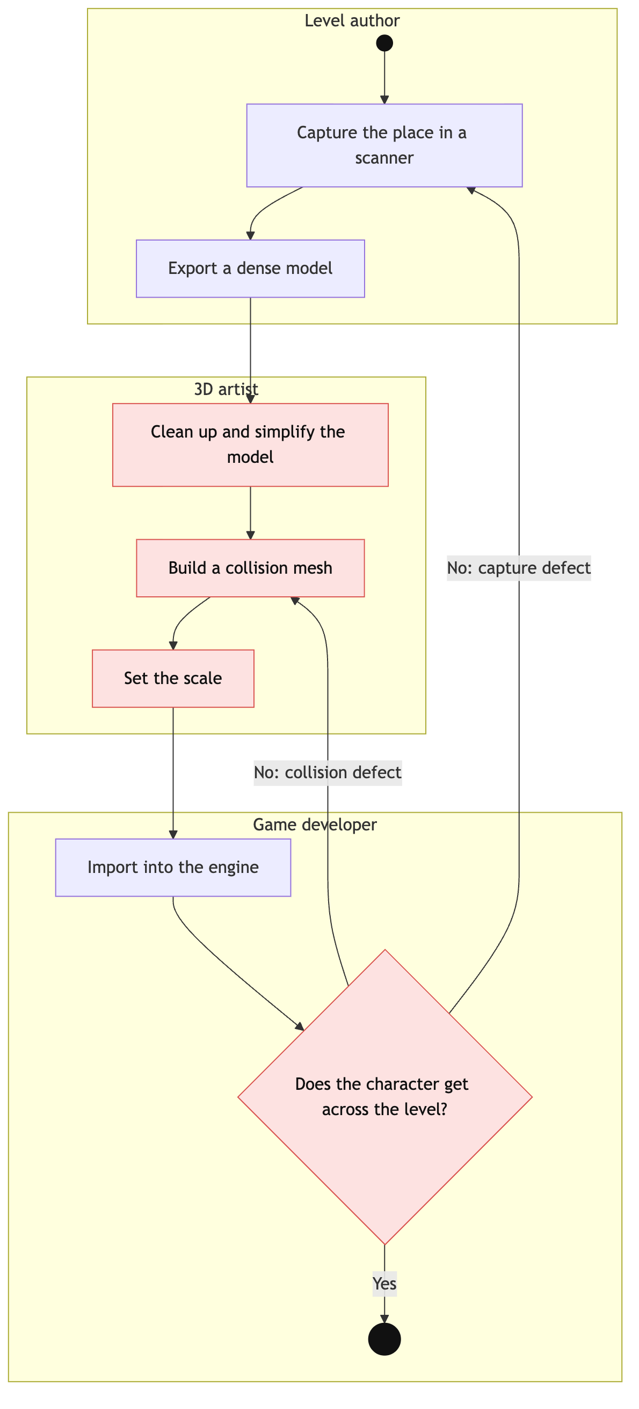
Image A.2.1. AS-IS process: a level from a real place today
UML activity diagram with swimlanes by role. Manual steps and the late check are marked in red. All three roles may be played by one person.

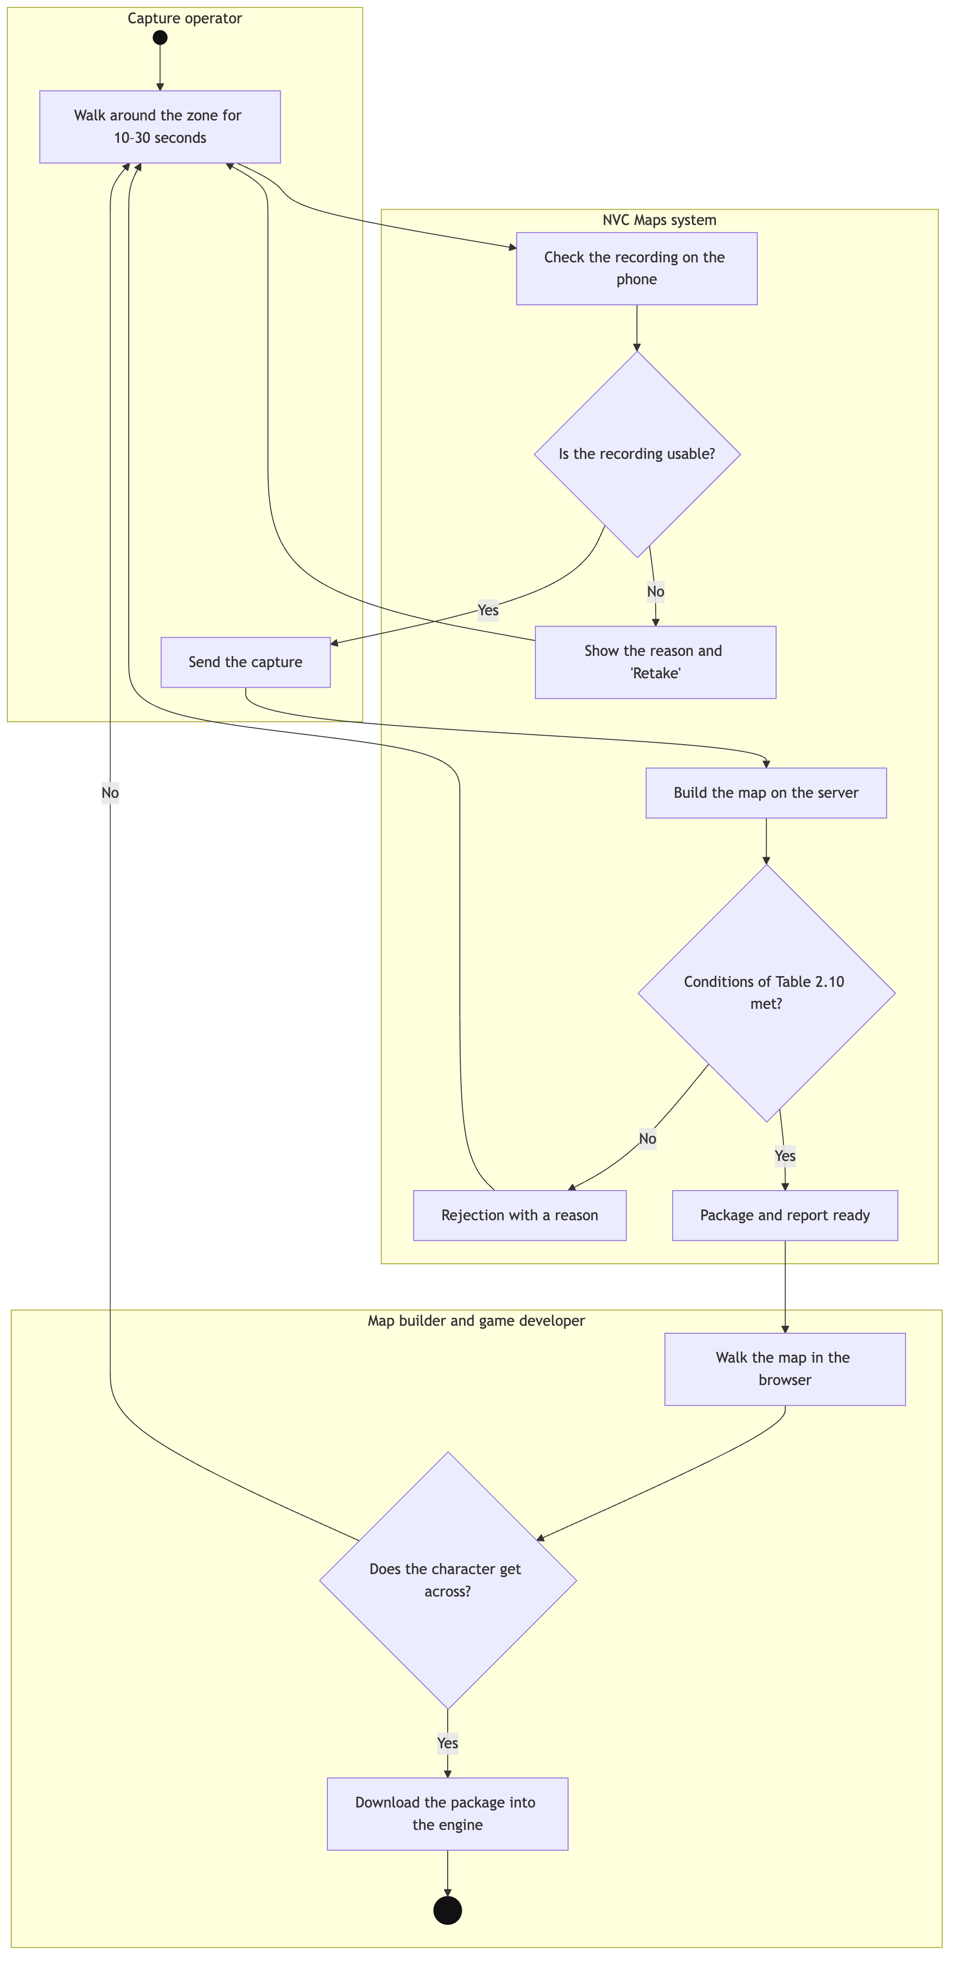
Image A.2.2. TO-BE process: a level with NVC Maps
UML activity diagram with swimlanes by role. There are no manual fixing steps; defects are caught by the recording check and the build rejection.

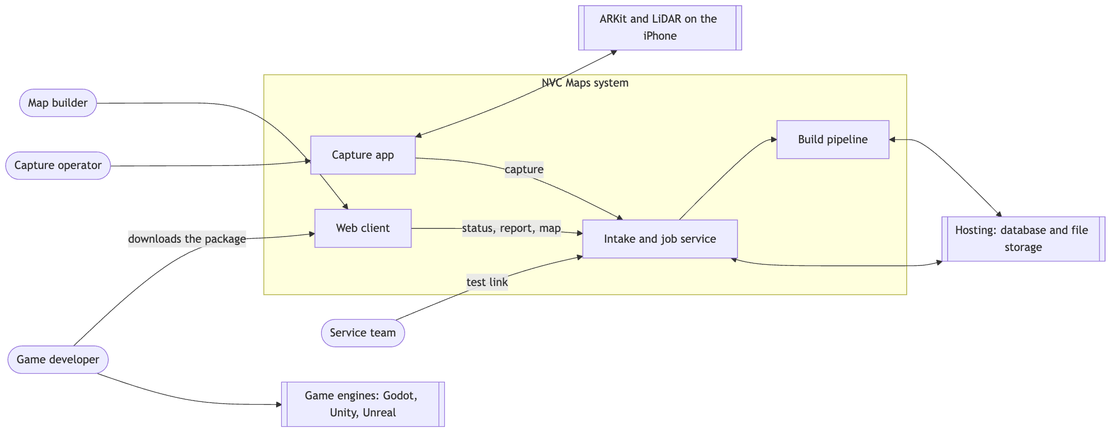
Image A.2.3. Context diagram

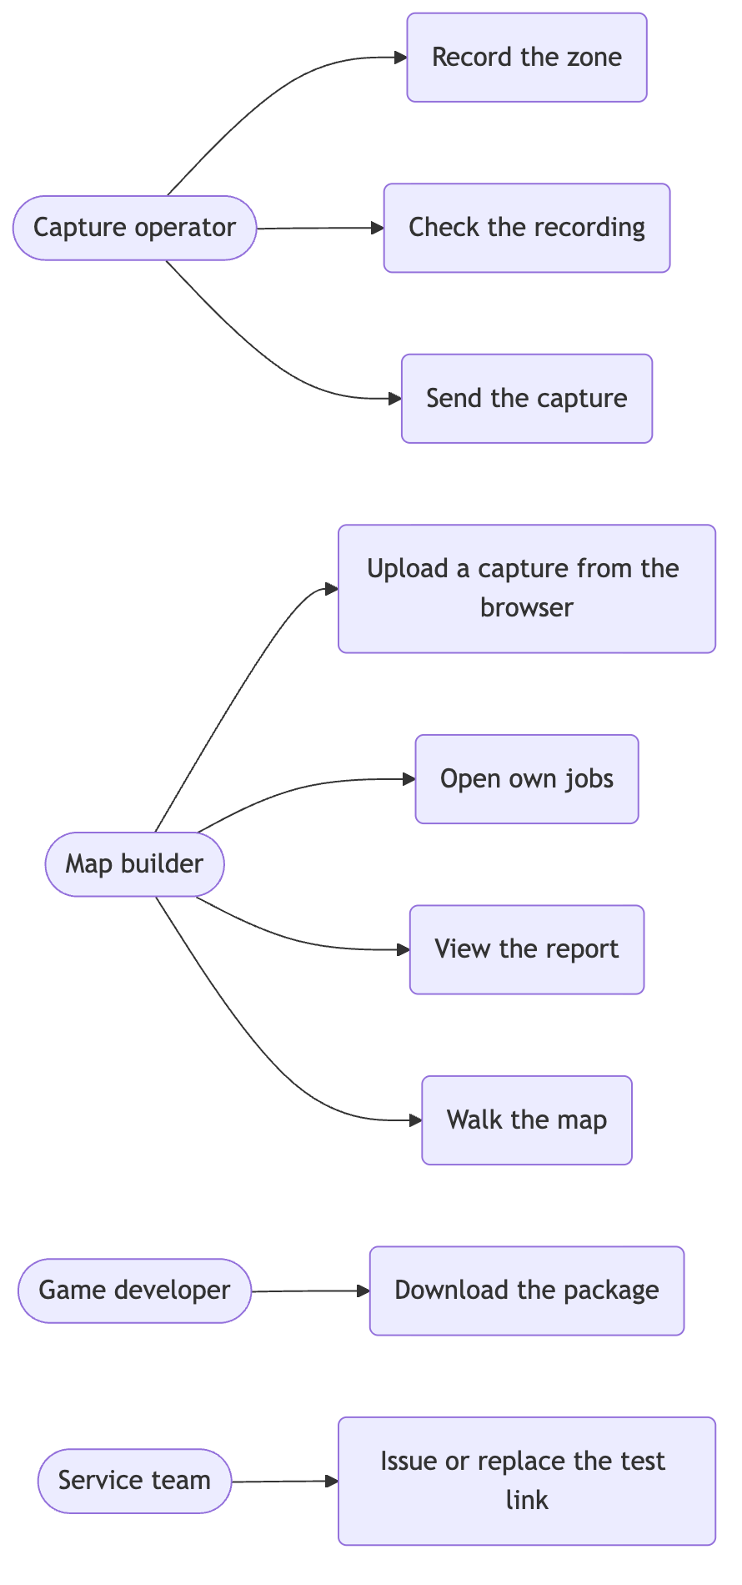
Image A.2.4. Use case diagram

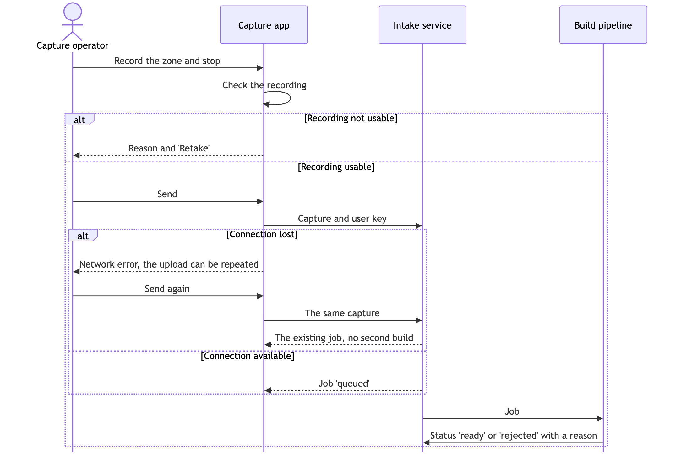
Image A.2.5. System sequence diagram of UC-1 "Capture and send an area"

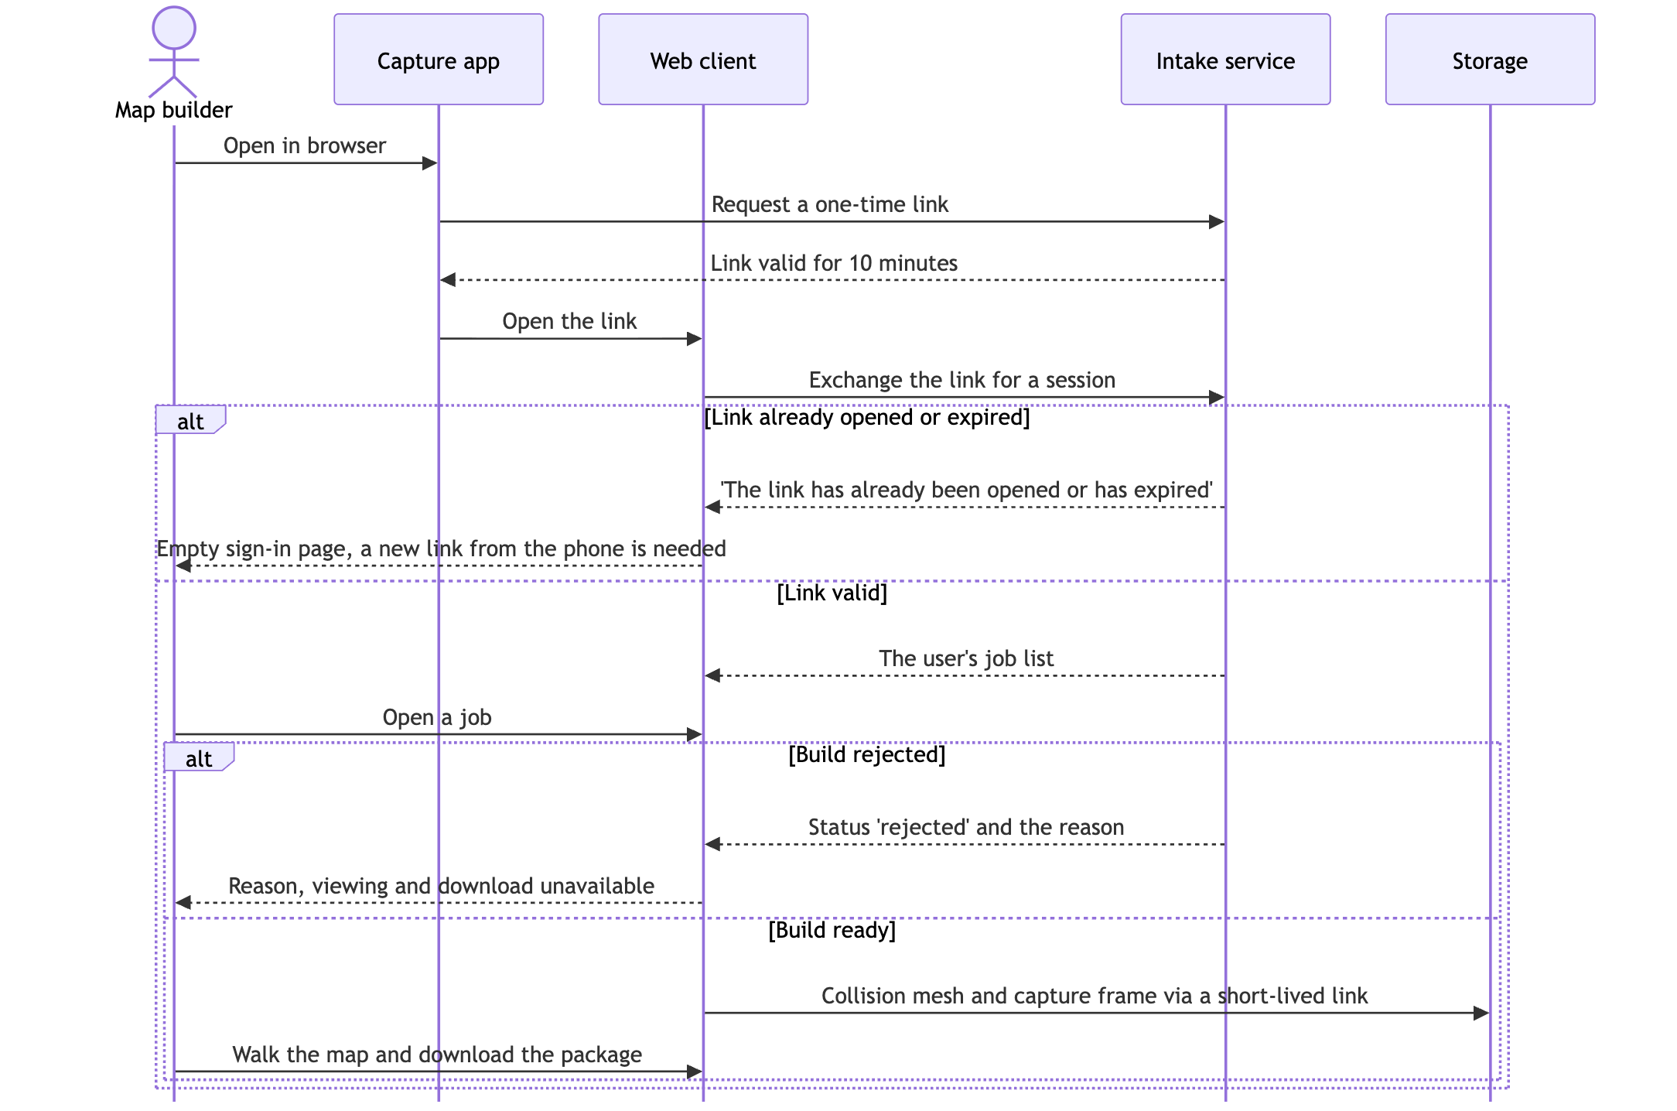
Image A.2.6. System sequence diagram of UC-2 "Check the map in the browser"

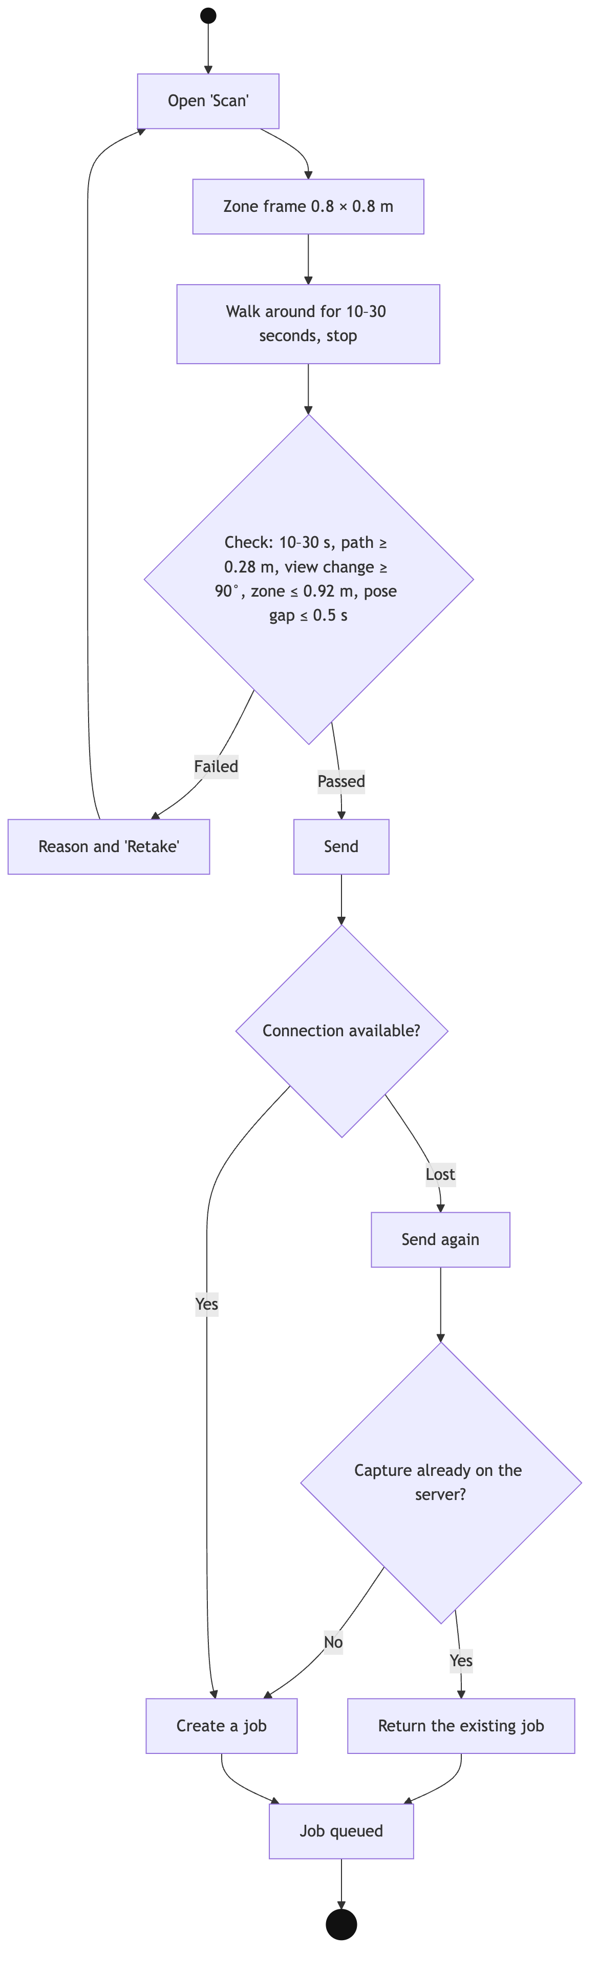
Image A.2.7. Activity diagram of UC-1 with alternative flows

STATEMENTS

Use of Artificial Intelligence
Use of AI tools
Tool | What it was used for | How
Claude (Anthropic), Claude Code | Searching for and comparing analogs, collecting market data | Web search on the author's queries; figures and descriptions found were checked against the links in the list of references
Claude (Anthropic), Claude Code | Structuring the document according to the business-analysis block requirements | The author set the section structure and product decisions; the model proposed wording, which the author checked and edited
Claude (Anthropic), Claude Code | Drafts of diagrams, tables and acceptance criteria | The model prepared drafts from the project requirements; the author checked them against the product
Claude (Anthropic), Claude Code | Translation into English | The model translated the author's Russian text; the author checked the translation
Claude (Anthropic), Claude Code | Document assembly | Scripts that build the website, PDF and DOCX from the source files

Decisions about the product, release scope, priorities and the choice of concept were made by the author. All facts from external sources are referenced.

